**NAME : YASH AGARWAL**

**EN.ROLL : B64015**

**WEEK 1 LAB B**

ANSWER 1,3

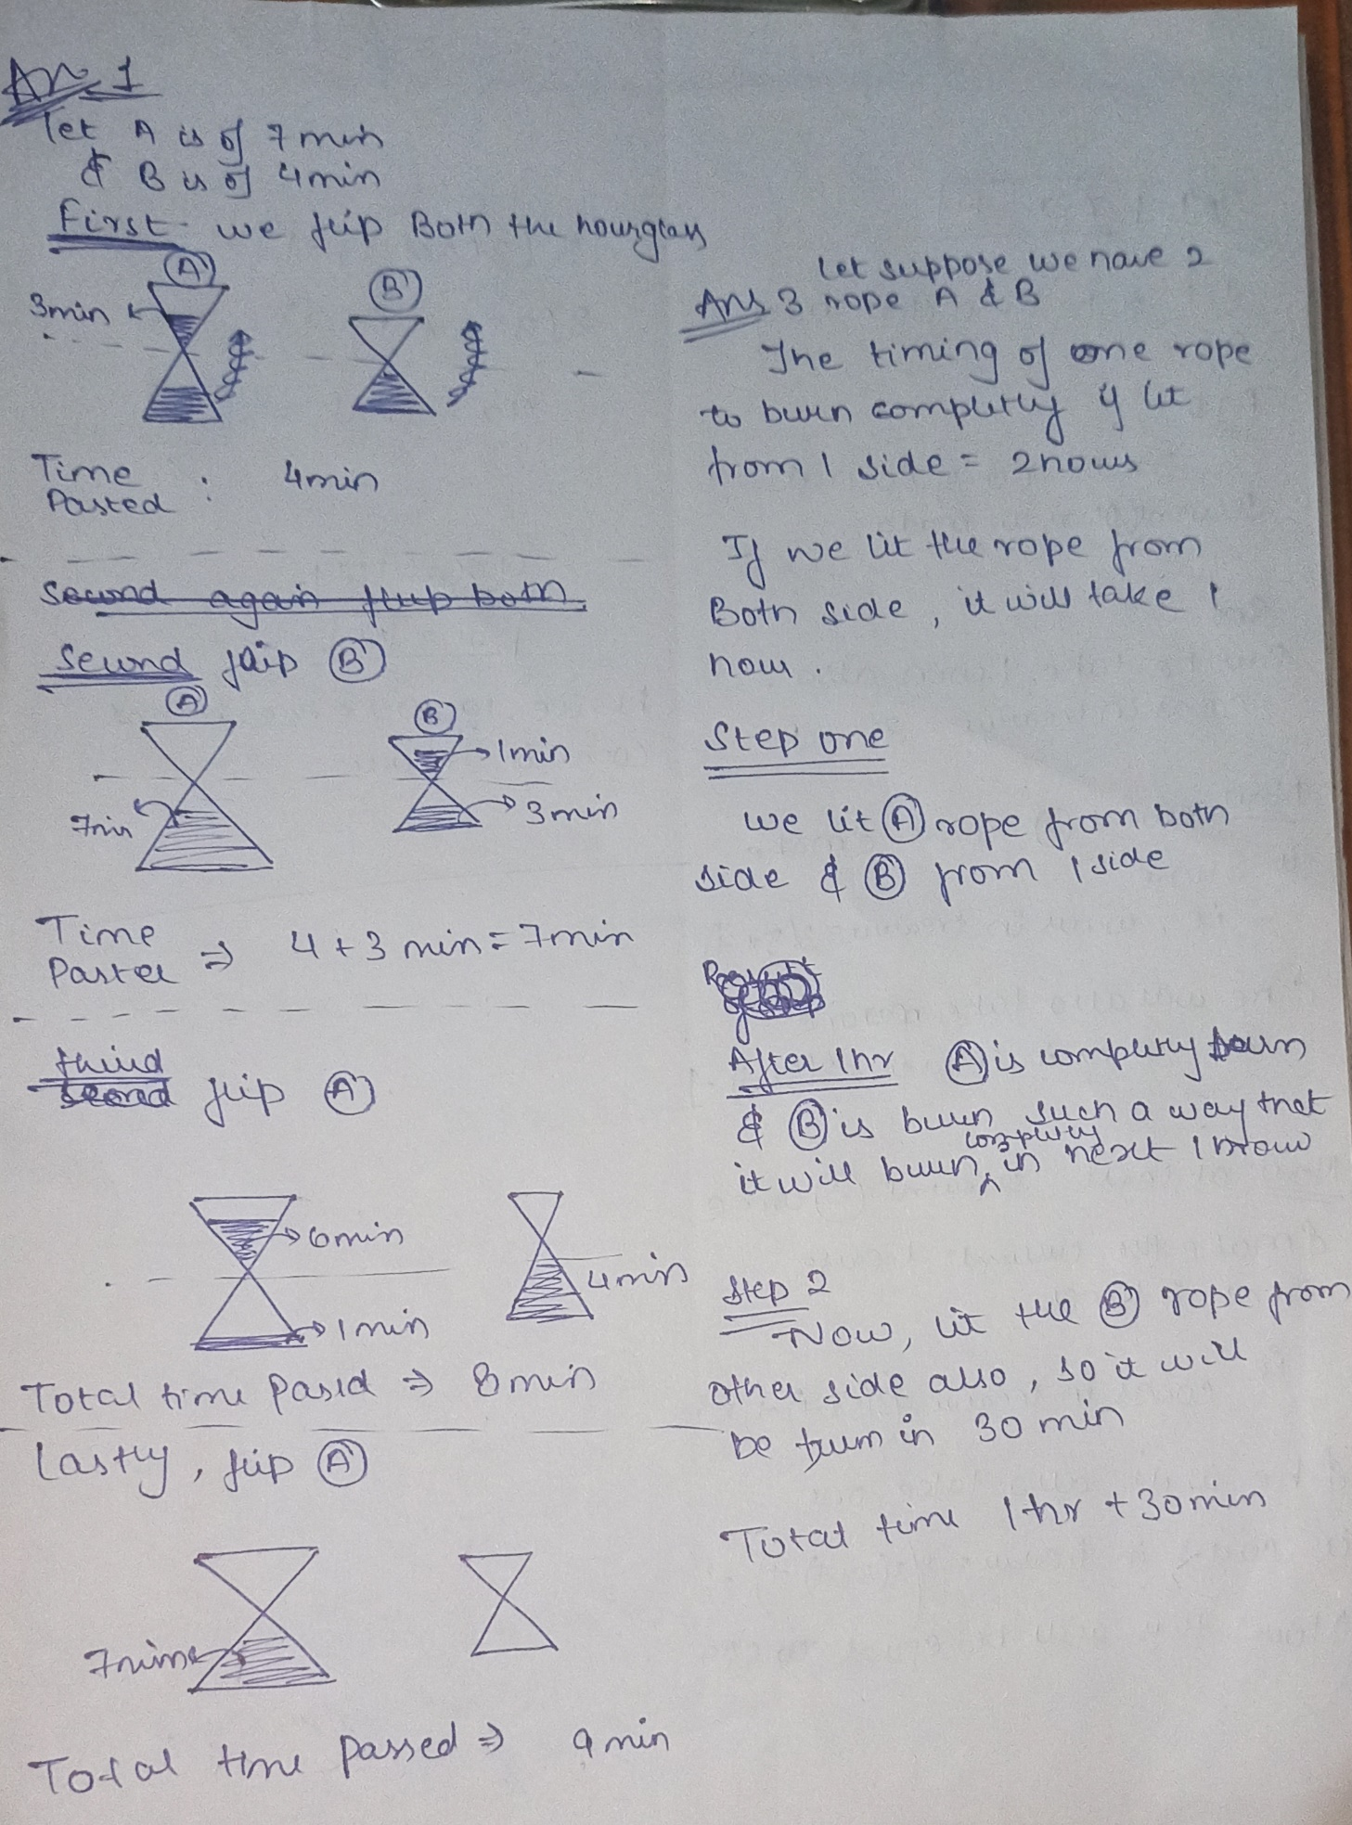

ANSWER 4

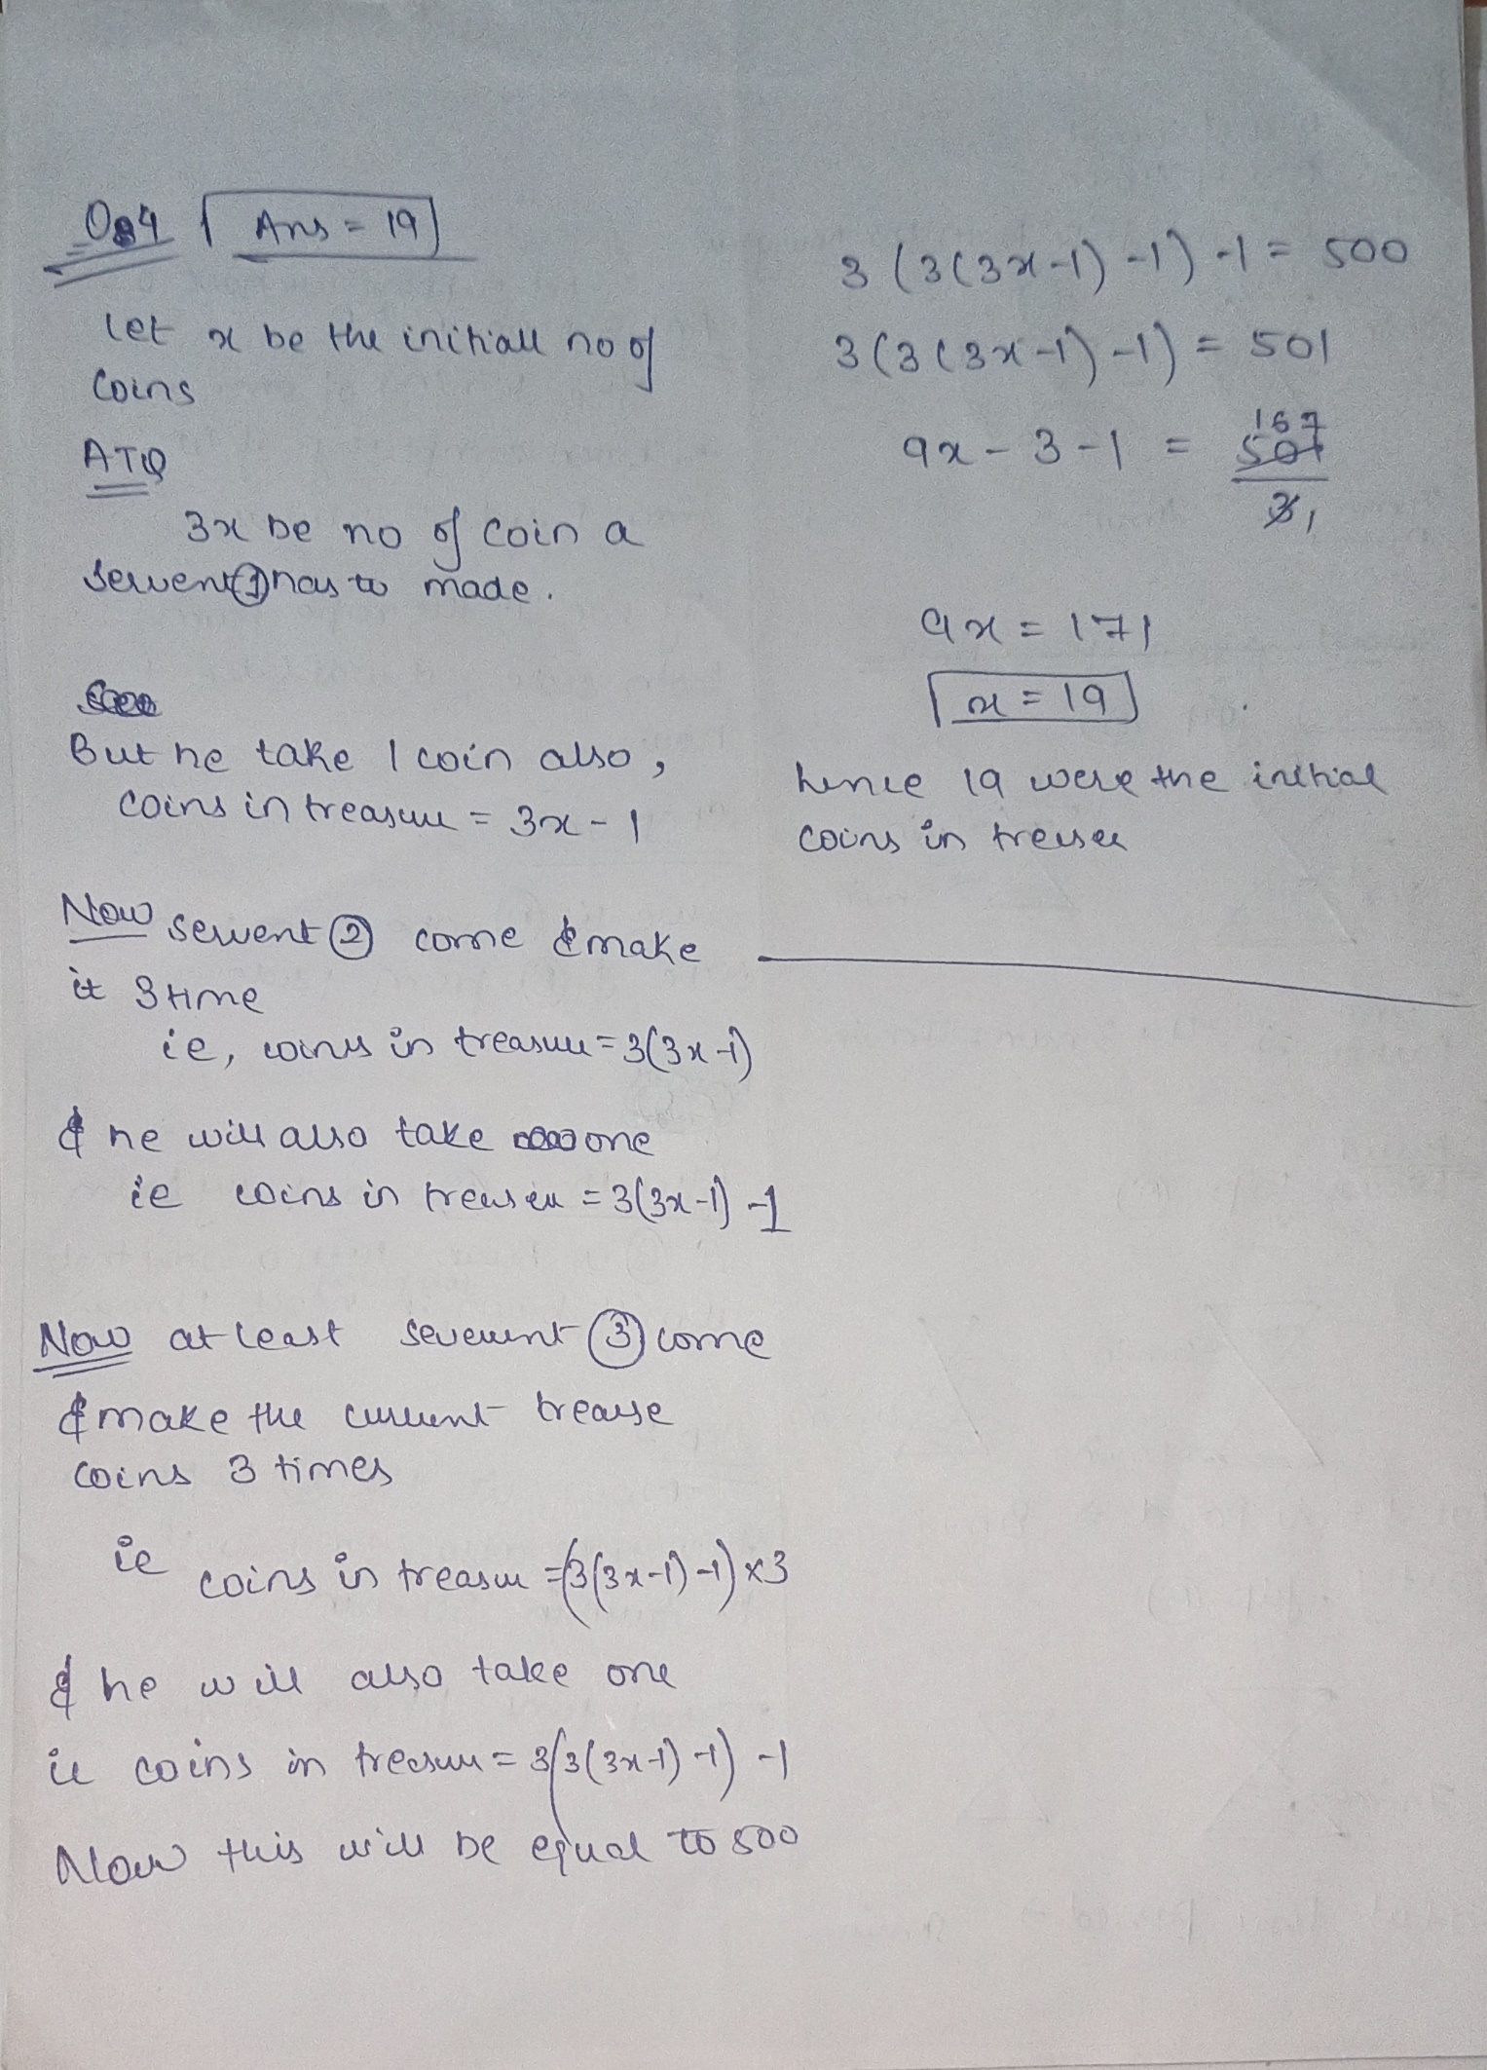

ANSWER 5 ,2

